Telco customer churn prediction system

1. Project Overview (Business Explanation)
Customer churn is one of the biggest challenges for subscription-based businesses.
The goal of this project is to predict which customers are most likely to discontinue their service, so the business can take action before losing revenue.
This project uses historical customer behavior, service usage patterns, and account details to build a machine learning model that identifies high-risk customers.
The final output is a Streamlit web application where a user (e.g., call-center agent, retention specialist, product manager) can enter customer details and instantly see:
- Churn probability (0–100%)
- Risk label (Likely / Not Likely)
- Business-friendly insights based on customer behavior
This helps leadership make data-driven retention decisions instead of relying only on intuition.

2. Why Churn Prediction Matters
Churn models support key business functions:
✔ Reduce Revenue Loss
Predicting churn helps focus retention offers on customers most likely to leave.
✔ Improve Customer Lifetime Value (CLV)
Interventions on the right customers directly improve LTV.
✔ Better Resource Allocation
Retention campaigns are expensive.
ML ensures efforts are targeted, not blanket-discounted.
✔ Increase Customer Satisfaction
Proactive outreach makes customers feel valued.

3. What This System Does (Non-Technical Summary)
The system:
1️⃣ Reads customer profile and service usage data
Examples:
- Tenure
- Contract type
- Monthly charges
- Services subscribed
- Whether they use support add-ons

2️⃣ Learns patterns of customers who previously churned
Machine Learning identifies which behaviors often lead to churn.

3️⃣ Predicts the probability of churn for any new customer
For example:
Customer Type | Churn Risk
Long-term, annual contract | Low
Month-to-month, high charges, low support usage | High

4️⃣ Provides clear business insights
Instead of black-box predictions, the model explains:
- Why the customer might churn
- Which factors influenced the score
- What actions may reduce churn
This is useful for non-technical teams like Sales, Marketing, and Customer Support.

5️⃣ Shows results in a simple web interface
A Streamlit web app makes the solution easy to use without technical knowledge.

4. What Data Was Used (Simple Terms)
Dataset: Telco Customer Churn from IBM
Size: ~7,000 customers
Type: Subscription business data
Includes:
- Customer demographics (gender, senior citizen, dependents)
- Subscription details (contract type, payment method)
- Billing information (monthly charges, total charges)
- Services used (internet service, security, tech support)
- Churn label (Yes/No)
No personally identifiable information was used.

5. Key Insights from Data (Leadership-Focused)
During analysis, several strong patterns emerged:
✔ 1. Month-to-month customers churn the most
They have the least commitment → highest risk.
✔ 2. Customers with high monthly charges are more likely to churn
Pricing pressure is a major churn driver.
✔ 3. Lack of support services increases risk
Customers without Tech Support or Online Security churn more.
✔ 4. New customers (tenure < 3 months) are at higher risk
Early experience is crucial for subscription retention.
✔ 5. Auto-payment customers are less likely to churn
Seamless billing reduces friction and accidental churn.
These insights translate directly into business actions.

6. How the Model Works (Simple Explanation)
The system doesn’t use hard-coded rules.
Instead, it learns from historical data.
In simple terms:
- It looks at thousands of past customers
- Learns which behaviors commonly lead to churn
- Applies the patterns to new customers
Output example:
“This customer has a 78% probability of churning.
Top reasons:
- Month-to-month contract
- High monthly charges
- No Tech Support subscription”
This helps business teams take targeted retention steps.

7. Architecture diagram
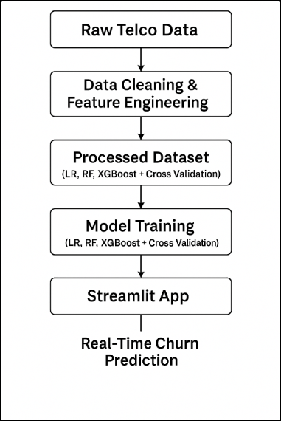

8. Why This Model Is Trustworthy
To ensure transparency and fairness, the system uses Explainable AI (SHAP) to:
- Show which features influenced the prediction
- Highlight positive/negative drivers
- Ensure decisions are interpretable, not black-box
Leadership teams often hesitate to use ML due to “black-box anxiety.”
Explainability solves that.

9. Streamlit Application (Business View)
The app lets non-technical users:
✔ Enter customer details
✔ Get instant churn risk
✔ View clear actionable insights
This helps:
- Retention teams prioritize customers
- Support agents tailor offers
- Managers plan campaigns
- Leadership monitor churn patterns
The app is simple enough for anyone to use.

10. Business Impact (High-Level)
If deployed as part of a retention workflow, this solution can help:
⭐ Increase retention by 10–30%
(by targeting high-risk segments)
⭐ Reduce marketing costs
(by focusing incentives only on at-risk customers)
⭐ Improve customer satisfaction
(by proactive outreach)
⭐ Strengthen executive decision-making
(by providing data-driven insights)
Even as a prototype, the system demonstrates the value of ML-driven retention.

11. Limitations & Future Enhancements (Executive View)
🔸 Limitations
- Dataset is a sample; real companies may need millions of rows.
- No real-time integration with billing systems.
- Predictions depend on input data quality.

🔹 Future Enhancements
- Retraining pipeline for real-time data
- API integration for CRM systems
- Dynamic customer segmentation
- Incorporate customer sentiment (calls, emails, chat data)
- Automated retention recommendations (discount vs outreach vs upsell)

12. Conclusion (Leadership Summary)
This project shows how Machine Learning can:
- Detect early churn signs
- Identify key behavioral drivers
- Enable targeted interventions
- Provide actionable insights to reduce revenue loss
It bridges technical ML modeling with business value creation, demonstrating end-to-end ownership from data processing to a client-ready application.

